**TItle :**

## **The medical industry is a lie, and you’ve been trapped in it**

**Logo:** 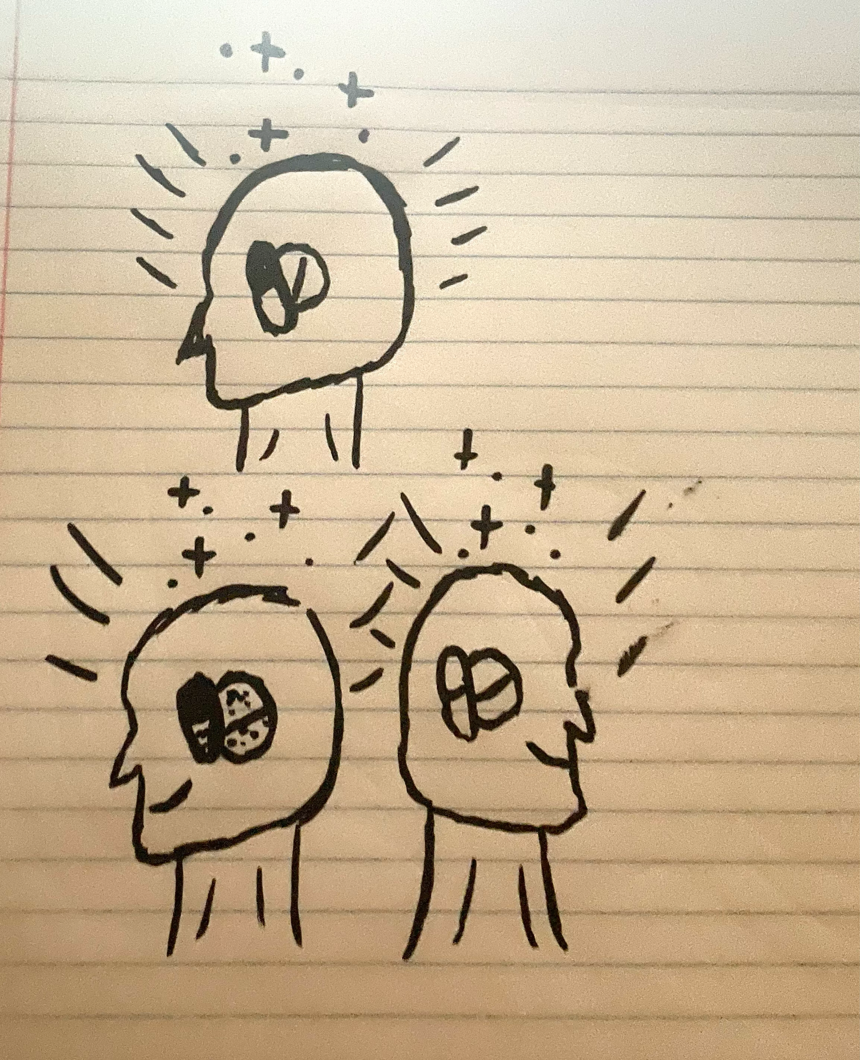

**Home Page:**

The placebo effect is the idea that your brain can convince your body that a fake treatment is actually a real one and is working to heal you. Scientists have found that the placebo effect not only convinces your brain that you are healing, but it has also been proven to be just as effective as some treatments used to heal. It is most often claimed that placebo medicines are only used in trials for real drugs to test their effectiveness against fake ones. In many of these trials, especially in recent years, patients felt the same effects or at least an improvement after taking the placebo medicine compared to the group that took a real drug. There are also accounts of doctors treating injured soldiers with the placebo effect due to a shortage of medicine at the time. An army doctor in World War II named Henry Beecher claimed that the placebo effect was effectively used to help treat gunshot wounds, severe pain, and sickness. The placebo effect has many different uses and has been proven effective in treating a variety of issues such as pain, illness, and mental illnesses. With so much research proving the effectiveness of placebo medicines and the undoubtedly cheaper price to make them, who’s to say they aren’t already being used as a form of treatment? The placebo effect could even be present in your everyday life without you ever realizing it, but if you don’t realize it’s there, it must be working, right?

**About Page:**

The entity representing this article and the research, along with the products, is a scientist researching the placebo effect in depth. This scientist has been collaborating with other researchers and gathering data about the use and effectiveness of placebo medicine. We have come to the conclusion that the placebo effect can be an effective form of treatment and, in many cases, is already being used as a source of treatment.

The purpose of our research is to educate people on the effectiveness of placebo medication in relation to treatment. Another reason for the research is to demonstrate that placebo medicine is actively being used without our knowledge. This medicine could be employed in an effective way to treat certain conditions more cheaply and without the actual use of drugs. A more sinister possibility is that this could be a tactic to inflate the price of medication while, in reality, patients are receiving placebo treatments, generating more profit for the bourgeoisie.

We already have significant evidence proving that placebo medications can create the sensation of being helped and even release chemicals in the body that contribute to feeling better, particularly in minor situations. Although the placebo effect can effectively trick your body into thinking it is better, it cannot actually heal a fatal injury, eliminate a terminal illness, or shrink a tumor. It is likely that real medicines are used for severe cases, but many cancer patients or critically injured individuals do not survive. While placebo pills cannot heal you, they can still trick your mind into believing that this treatment might save you or improve your condition.

This mental boost may help your mood, which in turn could aid the healing process; however, you would be paying a premium price for a medicine that contains no active ingredients and may only have a limited effect on your mood. In cases such as pain relief, sickness, and mental health, who is to say that any of that medicine actually contains active drugs? If placebo drugs are cheaper to produce and still work like real drugs, who can guarantee that all these name-brand, top-shelf, expensive medications are genuine medicine at all?

It’s common knowledge that if you have a headache or pain, you take ibuprofen or another drug to relieve it. This has become a habitual concept for most people. We associate these pills with recovery and the alleviation of pain. Because we believe so confidently that they will help us, they most likely will. Given this belief, do large brand companies really need to include active ingredients in their pills? They could have switched from real drugs to placebos years ago, and we would never have known. Furthermore, the original formulas could have been fake from the very start; they might have been placebos all along.

As the placebo effect remains effective, we are essentially paying for nothing, convincing ourselves that we are purchasing the best medicine available to heal ourselves. This deception is empowering the bourgeoisie, giving them more money, and control over the proletariat middle class—citizens of this country. The false knowledge we assume to be real about the medical industry and our health serves as a method to keep us controlled and uninformed about the true nature of our reality as a society and a species.

**Memorial: Not sure on what to write**

**3 Pieces of Research:**

1. Your mind can be a powerful healing tool when given the chance. The idea that your brain can convince your body a fake treatment is the real thing — the so-called placebo effect — and thus stimulate healing has been around for millennia. Now science has found that under the right circumstances, a placebo can be just as effective as traditional treatments.The placebo effect is more than positive thinking — believing a treatment or procedure will work. It's about creating a stronger connection between the brain and body and how they work together.
2. How placebos work is still not quite understood, but it involves a complex neurobiological reaction that includes everything from increases in feel-good neurotransmitters, like [endorphins](https://www.health.harvard.edu/mind-and-mood/endorphins-the-brains-natural-pain-reliever) and [dopamine](https://www.health.harvard.edu/mind-and-mood/dopamine-the-pathway-to-pleasure), to greater activity in certain brain regions linked to moods, emotional reactions, and self-awareness. All of it can have therapeutic benefits. The placebo effect is a way for your brain to tell the body what it needs to feel better.
3. Placebos often work because people don't know they are getting one. But what happens if you know you are getting a placebo?A study published in *Science Translational Medicine* explored this by testing how people reacted to migraine pain medication. One group took a migraine drug labeled with the drug's name, another took a placebo labeled "placebo," and a third group took nothing. The researchers discovered that the placebo was 50% as effective as the real drug to reduce pain after a migraine attack.
4. The researchers speculated that a driving force beyond this reaction was the simple act of taking a pill. People associate the ritual of taking medicine as a positive healing effect. Even if they know it's not medicine, the action itself can stimulate the brain into thinking the body is being healed.
5. How can you give yourself a placebo besides taking a fake pill? Practicing self-help methods is one way. Engaging in the ritual of healthy living — eating right, exercising, yoga, quality social time, meditating — probably provides some of the key ingredients of a placebo effect.

<https://www.health.harvard.edu/newsletter_article/the-power-of-the-placebo-effect>

**Any images:**

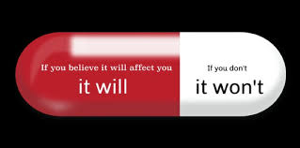

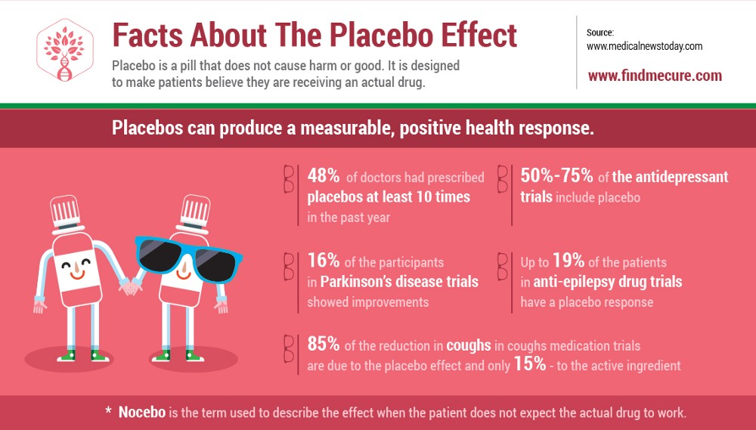

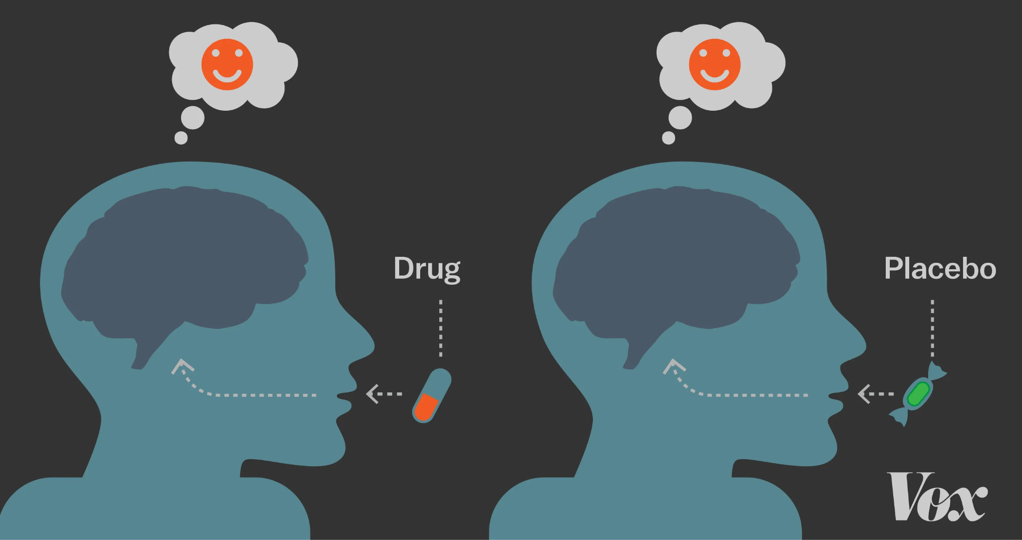

**Videos to support evidence:**[**https://www.youtube.com/watch?v=JcPwIQ6GCj8**](https://www.youtube.com/watch?v=JcPwIQ6GCj8)

**I like this video because it conveys the idea that the placebo effect is used for broader treatments, such as gunshot wounds, which was directly mentioned by the speaker. The video also discusses the use of placebos not only in pills but also in capsules, injections, and even machines. All of this combined gives me the impression that the placebo effect is utilized much more widely than just in testing and trials, so I think it can help support my argument.**

**Recruitment: Not sure on what to do**

**Product:**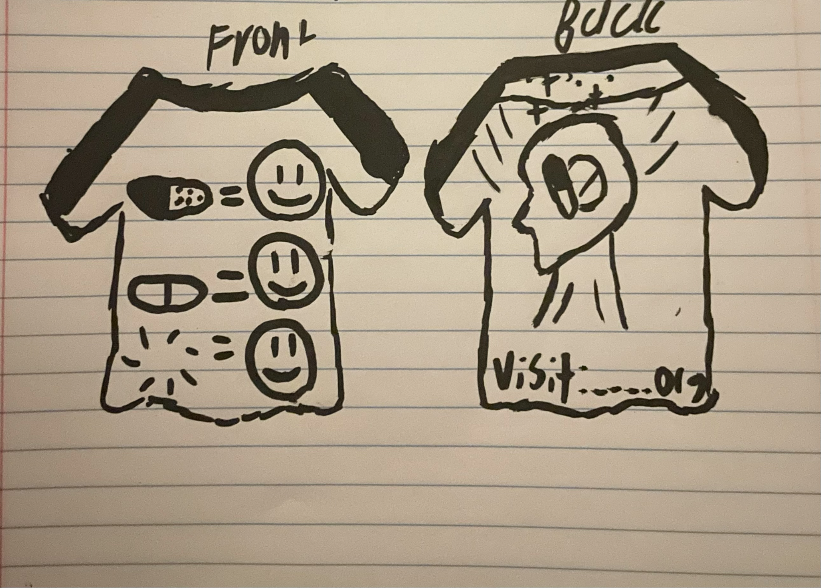

**Conclusion:**

As long as the so-called “common knowledge” about medicine and health remains unchanged, the placebo effect continues to be effective. We believe we know a fair amount about medicine and health because we know what to take when we’re sick, have a headache, can’t sleep, or are feeling depressed. We take these medicines without a second thought, relying on what we’ve been told by manufacturers or others who have used them.

But do we actually know which compounds in these drugs make us feel better? Are we aware of the science behind the chemicals and how they affect our brains when they enter our bodies? We read the labels with the ingredients to assure ourselves that the medicine contains something effective, but do we truly understand what any of those so-called ingredients are?

This deception empowers the bourgeoisie, giving them more money and control over the proletariat—working class citizens of this country. The false knowledge we assume to be real about the medical industry and our health serves as a method to keep us controlled and uninformed about the true nature of our reality as a society and a species.

These misconceptions, along with various other systems of misinformation, have been embedded in our society for a long time, creating a powerful force capable of deceiving and controlling the entire population without us even realizing it. At some point, we must choose: remain controlled and doomed, or we the proletariat overthrow the bourgeoisie which has controlled and used us.